**FPT ACADEMY INTERNATIONAL**



**FPT – APTECH COMPUTER EDUCATION**

**MEDICONNECT**

|  |  |  |
| --- | --- | --- |
| **Supervisor.** | **Lê Mộng Thúy** | |
| **Batch.** | **T3.2508.E1** | |
| **Group.** | **4** | |
| **Serial No.** | **Student Name** | **Enrollment Number** |
| **1** | **ĐÀO NHUẬN PHÁT** | Student1685476 |
| **2** | **HUỲNH THUẬN ĐẠT** | Student1685477 |
| **3** | **MAI TRỌNG TÍN** | Student1685518 |
| **4** | **LÊ TRỌNG HOÀNG** | Student1686150 |

Month 01 Year 2026

CONTENT

REVIEW 1 3

* 1. ACKNOWLEDGMENTS 3
  2. EPROJECT SYNOPSIS 3
  3. EPROJECT ANALYSIS 4
     1. FEASIBILITY STUDY 4
     2. DATA ANALYSIS 5
     3. SYSTEM OVERVIEW
     4. USER CLASSES AND ROLES
     5. BUSINESS RULES
     6. FUNCTIONAL REQUIREMENTS
     7. NON-FUNCTIONAL REQUIREMENTS 9

REVIEW 2 10

1. EPROJECT DESIGN 10
   1. DATA FLOW DIAGRAM (DFD) 26
   2. ENTITY RELATIONSHIP DIAGRAM (ERD) 32
   3. FLOW CHART 38
   4. PROCESS DIAGRAM
   5. DATABASE ENTITY RELATIONSHIP (ERD)

# REVIEW 1

* 1. **Acknowledgments**

Our team would like to express our gratitude to all the individuals and organizations who have supported and accompanied us throughout the eProject process.

First, our team would like to express our deepest gratitude to the school's administration and all the lecturers for their dedicated teaching, imparting valuable knowledge, and providing favorable conditions for us to complete this project.

Secondly, our group would like to express our sincerest gratitude to our supervising lecturer, Ms. Le Mong Thuy, who has always shown concern, provided dedicated guidance, offered valuable suggestions, and supported the group throughout the eProject implementation process. Her guidance and practical experience were crucial in helping the group complete the project on time and achieve the set goals.

Even though our group has done our best effort, due to limited time and experience, this report will have its shortcomings. Our group hopes to get valuable insight and guidance from Ms. Thuy and other lecturers to refine the project more in the future.

Our group gives our most sincere thanks to everyone.

* 1. **eProject Synopsis**

MediConnect is a web application focused on digitizing the scheduling process between patients and doctors. The system resolved many issues like long waiting times, difficulties in finding the right specialist, and manual medical appointment management. By directly connecting patients with doctors through a single platform, Mediconnect optimized healthcare for the community.

**1.3. eProject Analysis**

* **Functional Requirements:**
  + **User:** Sign up/ Login, search for doctors by filter (City, Specialty), booking, views medical records and submit review.
    - **When not sign in:** View latest news, view system introduction, submit contact information.
    - **When signed in:** All functions available according to role.
  + **Doctors:** Manage timeslots, confirm or cancel appointments, update the patient diagnosis/prescription.
  + **Admin:** Managing system categories, moderating news content, handling contact feedback, and managing account status (Active/Inactive).
* **Non-Functional Requirements:**
  + **Security: Password must be Hashed Password, strict user role-based access control.**
  + **Performance: The system responds quickly when querying the doctor list.**
  + **Interface: Friendly, easy to use on both web and mobile.**

**1.3.1. Feasibility Study**

* **Technical Feasibility:** Use popular technology like PHP/Java for Backend and MySQL for database, help preserving stability and easy maintenance.
* **Operation Feasibility:** The system was designed based on the  “Centralized” model, which helps reduce fragmented data storage, allowing patients and doctors easy access to information through a single account.

**1.3.2. Data Analysis**

* **Data Integrity**: Using Foreign Keys like ‘doctors id’, ‘patient id’ in Appointments table to ensure the data would not be orphaned.
* **Main relationship:**
  + **One-to-many:** One city will have many doctors; One doctor will have many free time slots.
  + **Many-to-many**: Doctors and Patients interacted through the Appointments board.

**1.3.3. System Overview**

Mediconnect is a centralized web application, designed to digitalize the interaction process between doctors and patients. The system acted as a “Digital Medical Coordination Center”, where we stored and managed all the data from account personal information, list of specialists, to the appointment-making process and medical records. The system ensure data consistency on a single database, helping all related parties to access information quickly and precisely.

**1.3.4. User Classes and Roles**

The system is divided with 3 main users with exclusive authority:

* **Administrator**: The user with highest authority. Manage system structure (City, Specialty), moderate medical news, manage account status (locked/unlocked), and monitor overall reports.
* **Doctor**: The user that provided service. Manage specialty documents, making timeslots, accept/manage appointments and record diagnosis/prescription for patients.
* **Patient**: The user that uses the service. Search for doctors, make appointments, receive notification, checking personal medical records and send feedback/rating after check up.
* **Guest:** This user can only use public address. Only being able to see the homepage, posts in the Medical Content section, search for doctors and making appointments are restricted.

**1.3.5 Business Rules**

These are core logic to ensure the authenticity of the data

* **Authenticity rule:** Only one email per account. Only one role per account (Admin, Doctor or Patient).
* **Appointment rule**: Patients can only make appointments on the available timeslots that was made as “Free” and the timeslot must not have any other appointment.
* **Feedback rule:** Patients can only send Feedback after the appointment status has changed to “Confirmed” or when the check up is finished.
* **Security rule:** Doctors can only view medical records of the patients that have made appointments with them before.
* **Anonymous access rule:** System required login before having access to further modules.

**1.3.6. Functional Requirements**

The specific functions that the system must perform:

* **Account Management**: Sign up, Log in, changing password and manage personal profile.
* **Search and Filter**: Find doctors based on name, specialty and city.
* **Appointment management:** Make appointments, cancel appointments (for patients) and confirm/deny appointments (for doctors).
* **Medical records**: Allowing doctors to input and patients to view diagnosis/prescription.
* **Notification**: Automatically send notification when there is a new appointment or when appointment status changed.

**1.3.7. Non-Functional Requirements**

System operational quality standards:

* **Security:** The user’s passwords must be encrypted according to standard procedures (Ex: Bcrypt). Protect system from common attack vulnerabilities such as SQL Injection.
* **Availability**: System must be operational 24/7 to ensure appointments can be made anytime.
* **Usability:** The interface must be intuitive and have a clear layout so that even elderly people (patients) can operate it easily.
* **Scalability:** The database structure must allow for easy addition of new hospitals or healthcare services in the future without altering the core architecture.

# REVIEW 2

**2. eProject Design**

**2.1 DATA FLOW DIAGRAM (DFD)**

**Level 0**

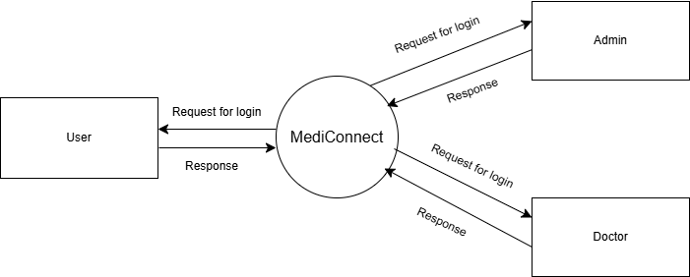

**ADMIN SIDE LEVEL 1**

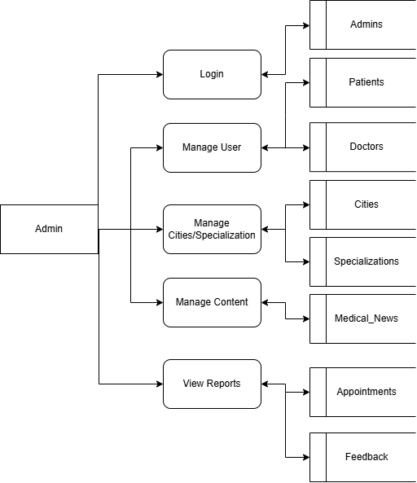

1.0 Login: Verify the Administrator account.

2.0 Manage Users: Manage Doctor and Patient accounts (Add, Delete, Edit, Lock).

3.0 Manage Cities/Specializations: Manage the list of cities and specialties.

4.0 Manage Content: Publish and manage medical articles.

5.0 Manage Content: Publish and manage medical articles.

**DOCTOR SIDE LEVEL 1**

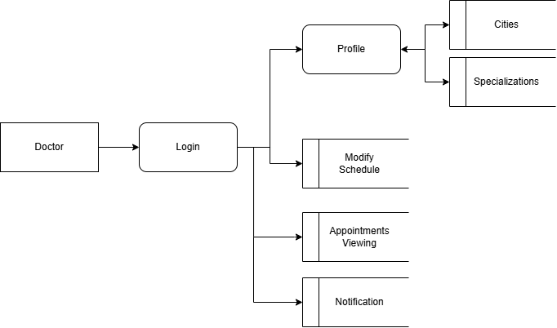

1.0 Login: Verify Doctor account.

2.0 Manage Profile: Update your personal information, qualifications, and expertise.

3.0 Manage Availability: Set available time slots.

4.0 View Appointments: See the list of patients who have scheduled appointments.

**PATIENT SIDE LEVEL 1**

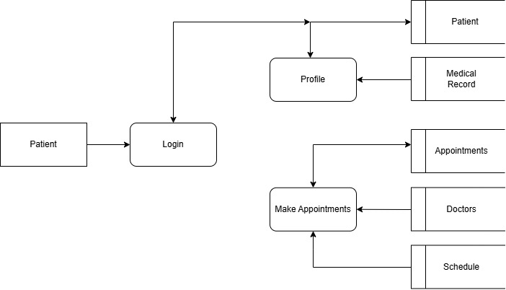

1.0 Registration/Login: Register an account and log in.

2.0 Search Doctor: Find doctors by criteria (City, Specialty).

3.0 Booking: Choose your doctor, select a time, and make an appointment.

4.0 History: View your medical history and upcoming appointments.

**ENTITY PROPERTIES**

**Users:** ID, Email, Password, Role (Admin/Doctor/Patient), Status.

**Doctors:** ID, User_ID, FullName, Specialization_ID, City_ID, Qualification, Bio, Phone.

**Patients:** ID, User_ID, FullName, Address, Phone, DOB, Gender.

**Cities:** ID, CityName.

**Specializations:** ID, SpecializationName, Description.

**Appointments:** ID, Doctor_ID, Patient_ID, Date, Time, Status (Pending/Confirmed/Cancelled), Symptoms.

**Doctor_Availability:** ID, Doctor_ID, DayOfWeek, StartTime, EndTime, IsAvailable.

**Medical_Content:** ID, Title, Category, Content, PublishedDate.

**Feedbacks:** ID, Appointment_ID, Patient_ID, Doctor_ID, Rating (1-5), Comment, Created_At.

**Notifications:** ID, User_ID, Title, Message, Is_Read (0/1), Type (Appointment/News/System), Created_At.

**Contact_Messages:** ID, Name, Email, Subject, Message, Status (Read/Unread), Created_At.

**Medical_Records:** ID, Appointment_ID, Diagnosis, Prescription, Doctor_Notes, Created_At.

**2.2 ENTITY RELATIONSHIP DIAGRAM (ERD)**

**Logical ERD:** Draw blocks and relationship connections (Example: 1 Doctor has multiple Appointments, 1 Patient has multiple Appointments).

**Physical ERD:** Draws details of column names, data types (Int, Varchar), and foreign keys.

**TABLE STRUCTURE FOR TABLE USERS**

|  |  |  |  |  |
| --- | --- | --- | --- | --- |
| **Column** | **Type** | **Null** | **Default** | **Description** |
| id | bigint(20) | No | AI | Primary Key |
| email | varchar(191) | No |  | Unique Email |
| password | varchar(255) | No |  | Hashed Password |
| role | enum('admin', 'doctor', 'patient') | No | 'patient' | User Role |
| status | enum('active', 'inactive') | No | 'active' | Account Status |
| created_at | timestamp | Yes | Current_Time |  |
| updated_at | timestamp | Yes |  |  |
| **image** | varchar(255) | Yes | NULL | Save the image file path/name.  (example: uploads/patients/img1.jpg) |

**TABLE STRUCTURE FOR TABLE CITIES**

|  |  |  |  |  |
| --- | --- | --- | --- | --- |
| **Column** | **Type** | **Null** | **Default** | **Description** |
| id | int(11) | No | AI | Primary Key |
| city_name | varchar(100) | No |  |  |
| created_at | timestamp | Yes |  |  |

**TABLE STRUCTURE FOR TABLE SPECIALIZATIONS**

|  |  |  |  |  |
| --- | --- | --- | --- | --- |
| **Column** | **Type** | **Null** | **Default** | **Description** |
| id | int(11) | No | AI | Primary Key |
| spec_name | varchar(150) | No |  | Name of specialty |
| image_url | varchar(255) | Yes |  | Illustrative image |
| created_at | timestamp | Yes |  |  |

**TABLE STRUCTURE FOR TABLE DOCTORS**

|  |  |  |  |  |
| --- | --- | --- | --- | --- |
| **Column** | **Type** | **Null** | **Default** | **Description** |
| id | bigint(20) | No | AI | Primary Key |
| user_id | bigint(20) | No |  | Foreign Key to user |
| full_name | varchar(191) | No |  |  |
| specialization_id | int(11) | No |  | Foreign Key to Specializations |
| city_id | int(11) | No |  | Foreign Key to Cities |
| qualification | text | Yes |  | Qualification/degree |
| phone | varchar(20) | No |  |  |
| bio | text | Yes |  | Introduction |
| created_at | timestamp | Yes |  |  |

**TABLE STRUCTURE FOR TABLE PATIENTS**

|  |  |  |  |  |
| --- | --- | --- | --- | --- |
| **Column** | **Type** | **Null** | **Default** | **Description** |
| **id** | bigint(20) | No | AI | Primary Key |
| **user_id** | bigint(20) | No |  | Foreign keys associated with the users table |
| **full_name** | varchar(191) | No |  | Full name |
| **phone** | varchar(20) | No |  | Contact number |
| **address** | text | No |  | Residency address |
| **dob** | date | Yes |  | Date of birth |
| **gender** | enum('Male', 'Female', 'Other') | Yes |  | Gender |
| **created_at** | timestamp | Yes | NULL | Account creation time |

**TABLE STRUCTURE FOR TABLE DOCTOR_AVAILABILITY**

|  |  |  |  |  |
| --- | --- | --- | --- | --- |
| **Column** | **Type** | **Null** | **Default** | **Description** |
| **id** | **bigint(20)** | **No** | **AI** | **Primary Key** |
| **doctor_id** | **bigint(20)** | **No** |  | **Foreign Key to Doctors** |
| **day_of_week** | **enum('Mon', 'Tue'...'Sun')** | **No** |  | **Day of week** |
| **start_time** | **time** | **No** |  | **Start time** |
| **end_time** | **time** | **No** |  | **End time** |
| **is_available** | **tinyint(1)** | **No** | **1** | **1: Available, 0: Not available** |

**TABLE STRUCTURE FOR TABLE APPOINTMENTS**

|  |  |  |  |  |
| --- | --- | --- | --- | --- |
| **Column** | **Type** | **Null** | **Default** | **Description** |
| **id** | **bigint(20)** | **No** | **AI** | **Primary Key** |
| **doctor_id** | **bigint(20)** | **No** |  | **Foreign Key to Doctors** |
| **patient_id** | **bigint(20)** | **No** |  | **Foreign Key to Patients** |
| **appointment_date** | **date** | **No** |  | **Appointment Date** |
| **appointment_time** | **time** | **No** |  | **Appointment Time** |
| **symptoms** | **text** | **Yes** |  | **Symptoms** |
| **status** | **enum('Pending', 'Confirmed', 'Cancelled',’Completed)** | **No** | **'Pending'** | **Status** |
| **created_at** | **timestamp** | **Yes** | **current time** |  |
| **update_at** | **timestamp** | **yes** | **null** |  |

**TABLE STRUCTURE FOR TABLE MEDICAL_CONTENT**

|  |  |  |  |  |
| --- | --- | --- | --- | --- |
| **Column** | **Type** | **Null** | **Default** | **Description** |
| **id** | **int(11)** | **No** | **AI** | **Primary Key** |
| **title** | **varchar(255)** | **No** |  | **Content title** |
| **category** | **varchar(100)** | **No** |  | **Category** |
| **content** | **longtext** | **No** |  | **content** |
| **author_id** | **bigint(20)** | **Yes** |  | **Foreign Key to Users (Admin)** |
| **published_date** | **datetime** | **Yes** |  |  |

**TABLE STRUCTURE FOR FEEDBACK**

|  |  |  |  |  |
| --- | --- | --- | --- | --- |
| **Column** | **Type** | **Null** | **Default** | **Description** |
| **id** | bigint(20) | No | AI | Primary Key |
| **appointment_id** | bigint(20) | No |  | Foreign Key to Appointments |
| **rating** | int(1) | No |  | Number of stars (1-5) |
| **comment** | text | Yes |  | Detailed feedback/comment |
| **created_at** | timestamp | Yes | Current_Time | Feedback/Comment day |

**TABLE STRUCTURE FOR TABLE NOTIFICATIONS**

|  |  |  |  |  |
| --- | --- | --- | --- | --- |
| **Column** | **Type** | **Null** | **Default** | **Description** |
| **id** | bigint(20) | No | AI | Primary Key |
| **user_id** | bigint(20) | No |  | Foreign Key to Users |
| **title** | varchar(255) | No |  | Notification title |
| **message** | text | No |  | Notification content |
| **is_read** | tinyint(1) | No | 0 | 0: Unread, 1: Read |
| **type** | enum | No | 'System' | Appointment, News, System |
| **created_at** | timestamp | Yes | Current_Time | Sending time |

**TABLE STRUCTURE FOR TABLE CONTACT_MESSAGES**

|  |  |  |  |  |
| --- | --- | --- | --- | --- |
| **Column** | **Type** | **Null** | **Default** | **Description** |
| **id** | int(11) | No | AI | Primary Key |
| **name** | varchar(100) | No |  | Sender’s name |
| **email** | varchar(191) | No |  | Contact email |
| **subject** | varchar(255) | Yes |  | Message subject |
| **message** | text | No |  | Message content |
| **status** | enum | No | 'Unread' | Status: Unread, Read |
| **created_at** | timestamp | Yes | Current_Time | Received time |

**TABLE STRUCTURE FOR TABLE MEDICAL_RECORDS**

|  |  |  |  |  |
| --- | --- | --- | --- | --- |
| **Column** | **Type** | **Null** | **Default** | **Description** |
| **id** | bigint(20) | No | AI | Primary Key |
| **appointment_id** | bigint(20) | No |  | Foreign Key to Appointments (Unique) |
| **diagnosis** | text | No |  | Doctor diagnosis |
| **prescription** | text | Yes |  | Prescription (Medicine name, dosage) |
| **doctor_notes** | text | Yes |  | Doctor’s note |
| **created_at** | timestamp | Yes | Current_Time | File creation date |

**2.3. FLOW CHART**

Flowcharts describe the logical steps involved in performing a specific function. The most important example is the Appointment Scheduling Flowchart.

* Start: Patient logs in.
* Search: Select Specialty/City.
* Selection: The system displays a list of doctors → The patient selects a doctor.
* Select appointment time: Display available time slots (from the Doctor Availability table).
* Procedure: Check if that time slot is already booked.
  + If yes: Request a different time slot.
  + If no: Record the date in the Appointments table with the status 'Pending'.
* Conclusion: A notification that your appointment has been successfully booked.

**2.4. Process Diagrams**

* **Patient Use Cases**: Register, Search for a doctor, Schedule an appointment, View medical records, Submit feedback.
* **Doctor Use Cases**: Update availability, Manage appointments, Record examination results (Diagnosis/Prescription).
* **Admin Use Cases:** User Management, Category Management (Cities/Specializations), News Browsing, Viewing Statistical Reports.

**2.5. DATABASE ENTITY RELATIONSHIP (ERD)**

|  |  |  |  |
| --- | --- | --- | --- |
| **Entity A** | **Entity B** | **Cardinality** | **Relationship Description** |
| **GROUP 1: ACCOUNTS** |  |  |  |
| Users | Patient_Profiles | 1 : 1 | Each user account with the "patient" role has exactly one patient profile. |
| Users | Doctor_Profiles | 1 : 1 | Each user account with the "doctor" role has exactly one specialist doctor profile. |
| **GROUP 2: CLINICAL DATA** |  |  |  |
| Specializations | Doctor_Profiles | 1 : N | A single medical specialist may have multiple doctors registered to practice. |
| Cities | Doctor_Profiles | 1 : N | A particular city may have many doctors/clinics operating. |
| Doctor_Profiles | Availability | 1 : N | A doctor can have several different available time slots throughout the week. |
| **GROUP 3: OPERATIONS** |  |  |  |
| Doctor_Profiles | Appointments | 1 : N | A doctor may manage and accept multiple appointments from patients. |
| Patient_Profiles | Appointments | 1 : N | A patient may schedule multiple appointments with different doctors. |
| Appointments | Medical_Records | 1 : 1 | Each post-examination appointment corresponds to only one copy of the medical record/results. |
| Appointments | Feedbacks | 1 : 1 | Each completed appointment allows only one review/feedback submission from the patient. |
| **GROUP 4: SYSTEM** |  |  |  |
| Users | Notifications | 1 : N | A user can receive multiple calendar reminders or news notifications. |

# REVIEW 3

## SITE MAP

**HOME SITE MAP**

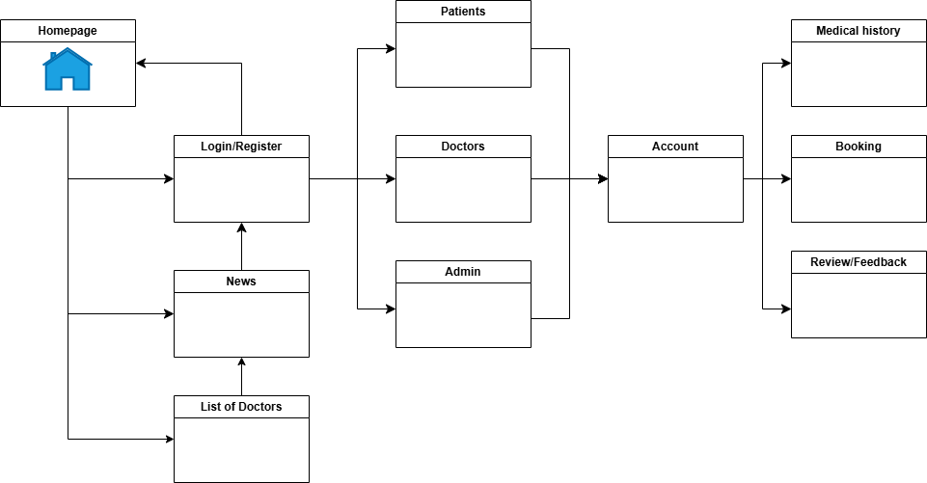

**DOCTOR SITE MAP**

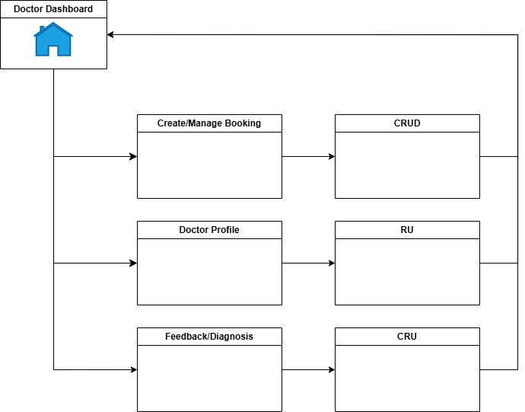

**PATIENT SITE MAP**

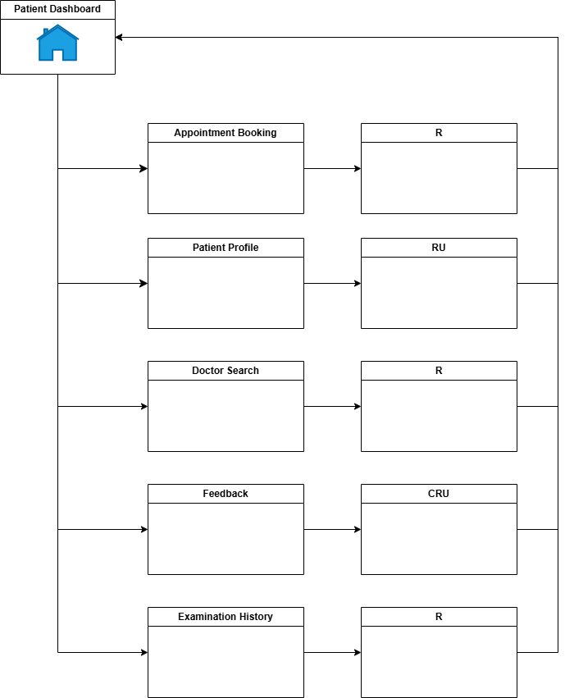

**ADMIN SITE MAP**

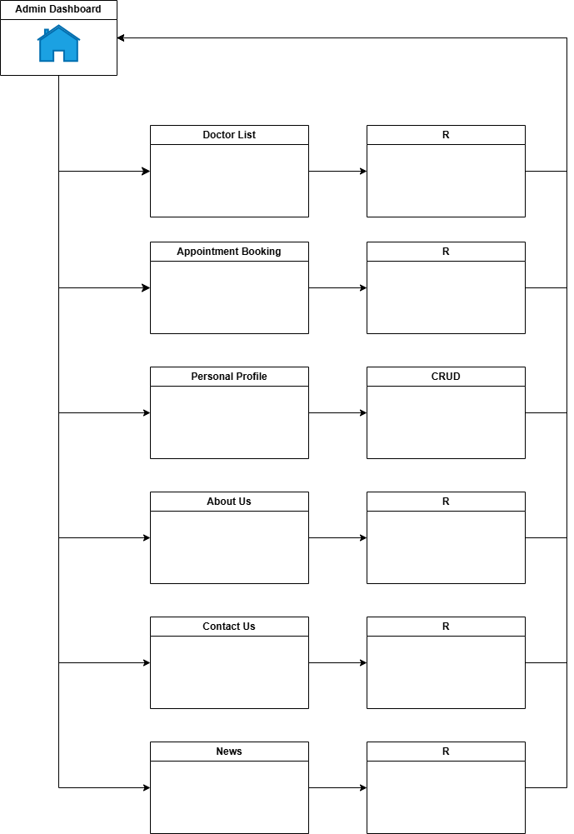

## MEDICONNECT WIREFRAME

**HOMEPAGE**

**DOCTOR DASHBOARD**

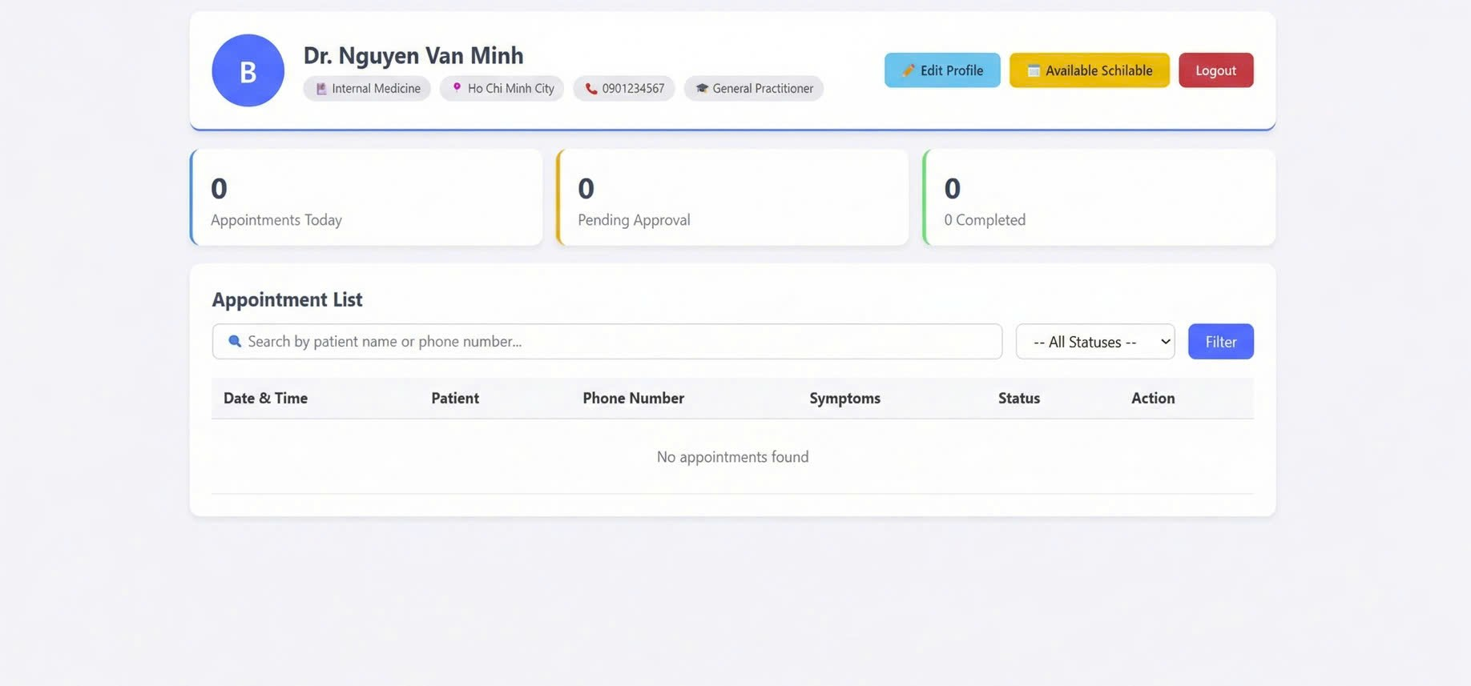

**DOCTOR TIMESLOT MANAGEMENT**

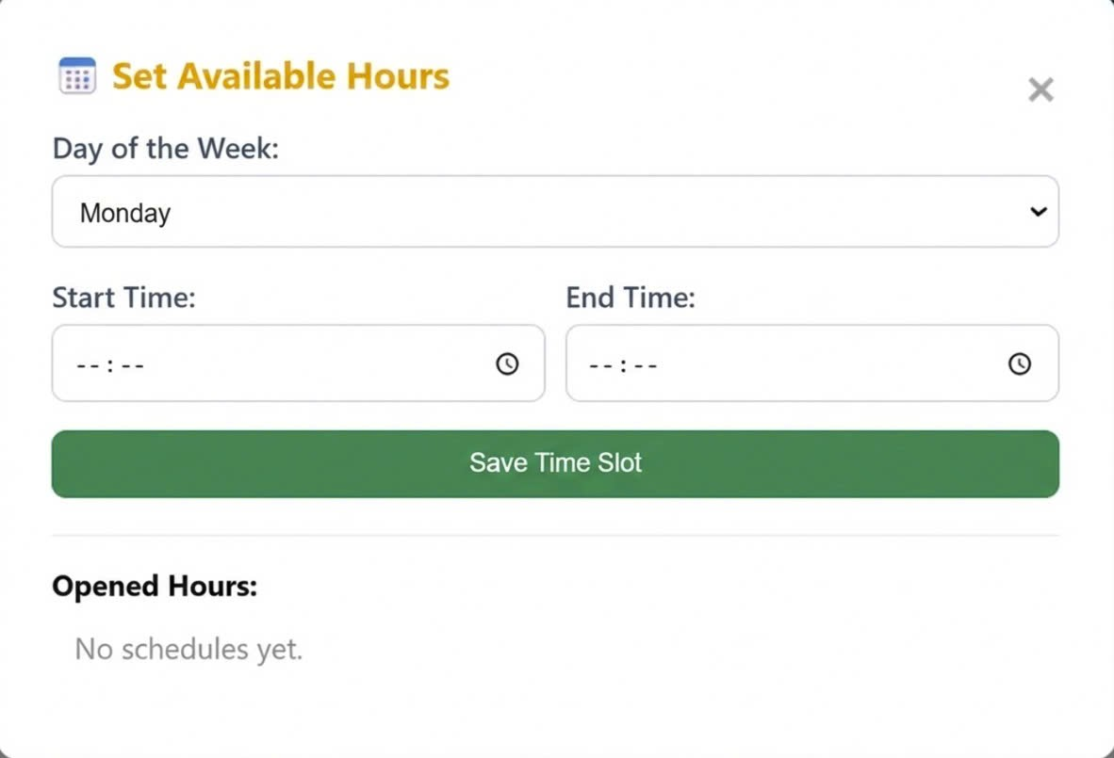

**DOCTOR PROFILE**

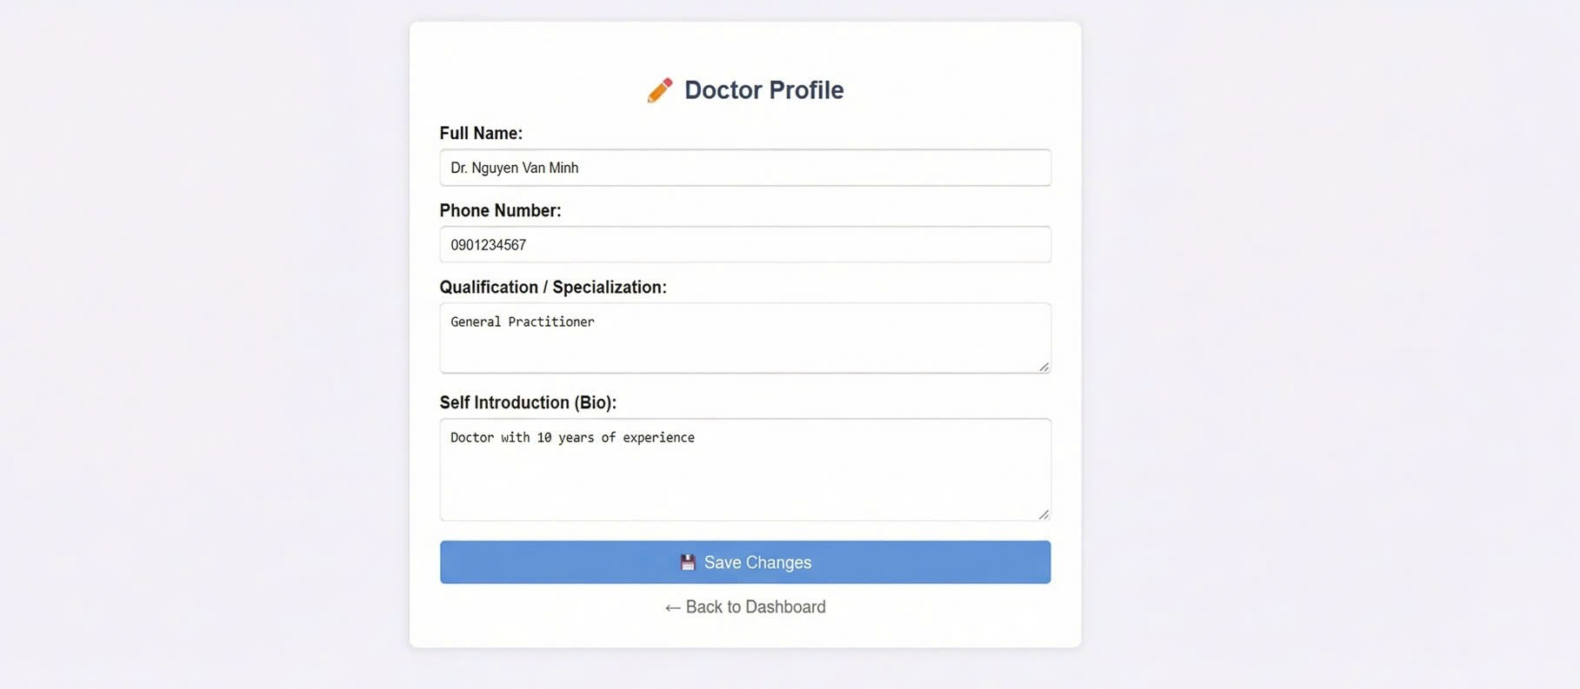

**PATIENT DASHBOARD**

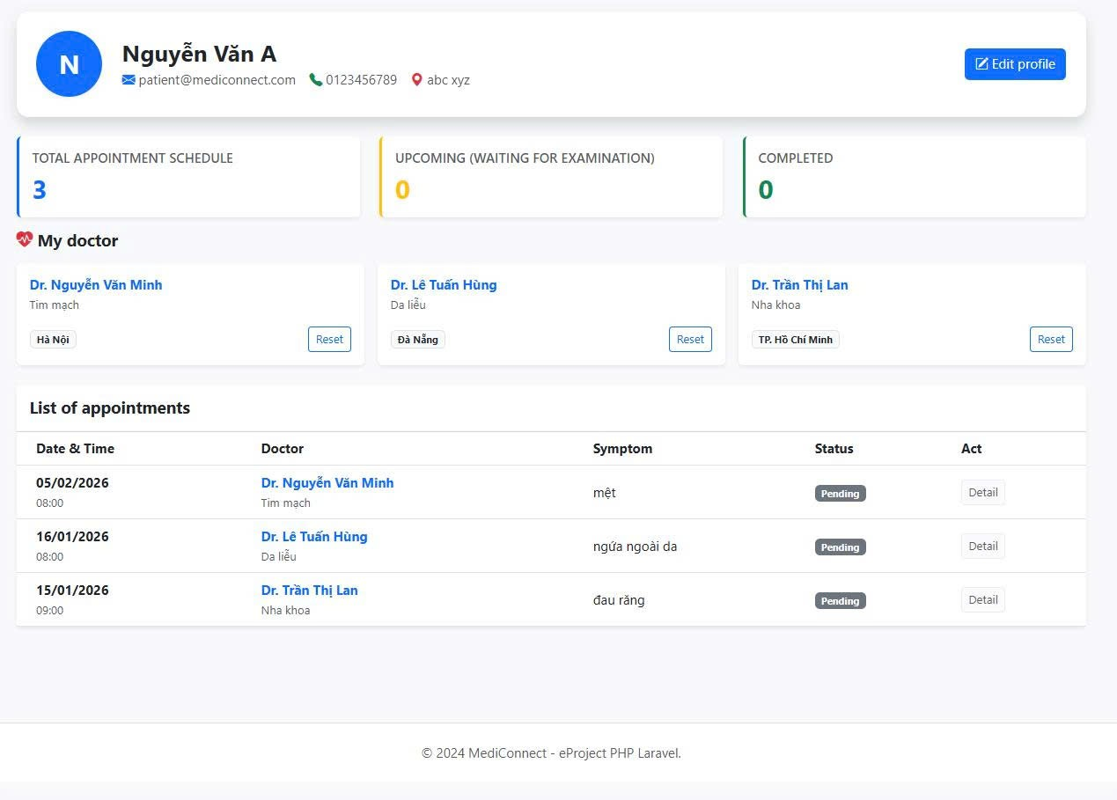

**APPOINTMENT BOOKING**

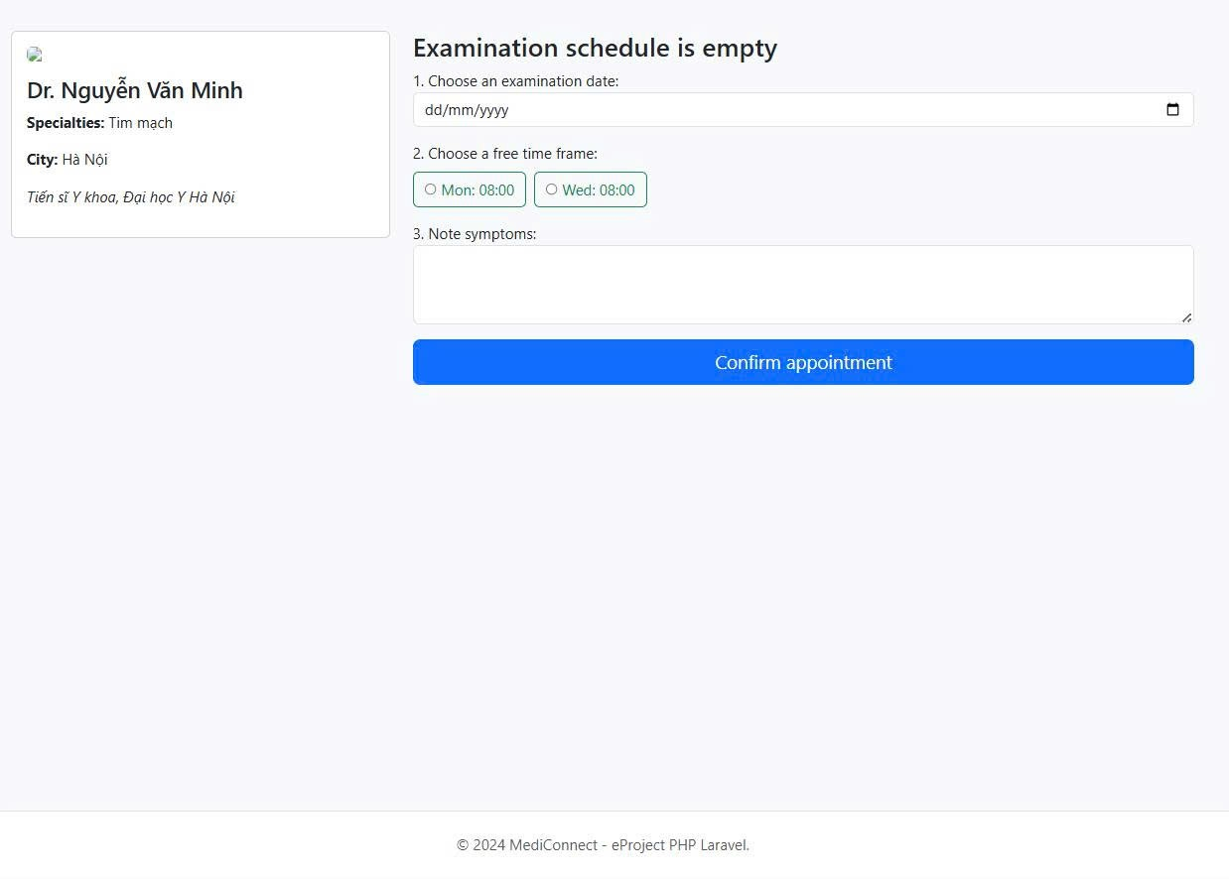

**SEARCH FOR DOCTORS**

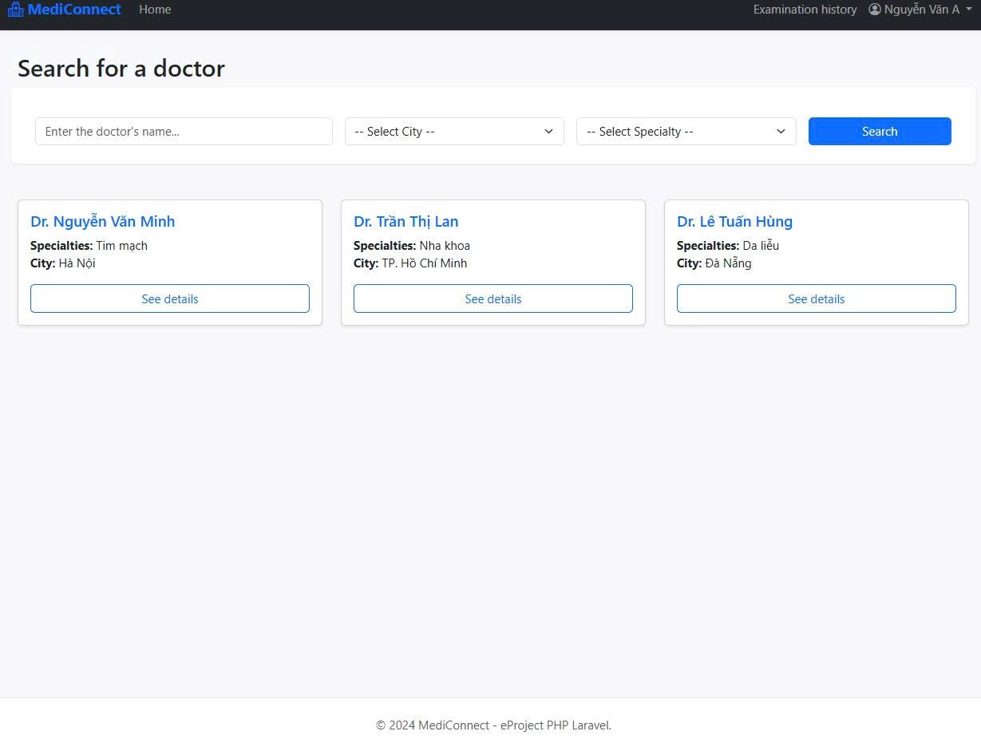

**MEDICAL HISTORY**

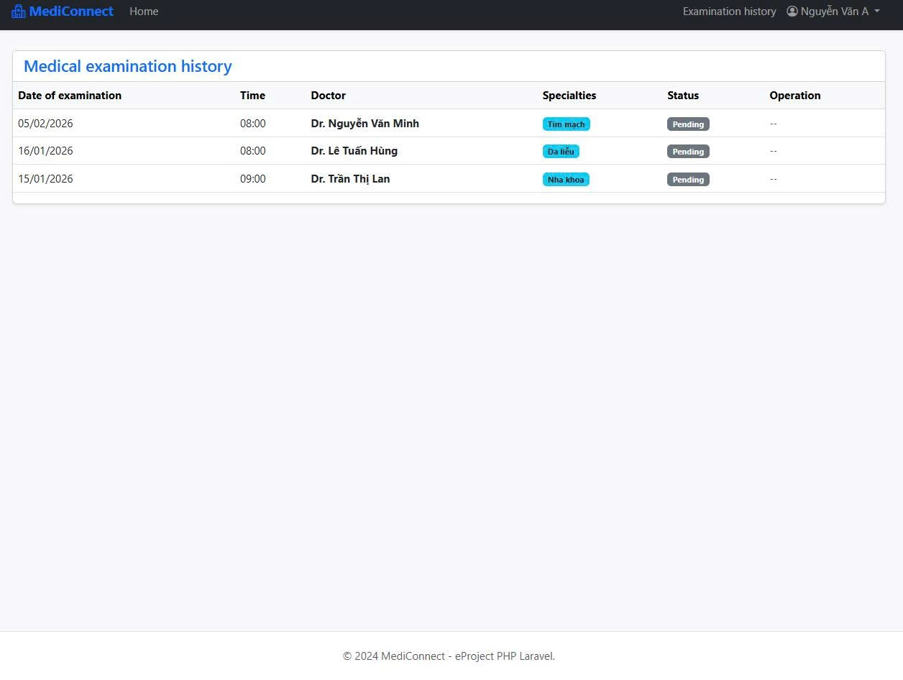

**MEDICAL NEWS**

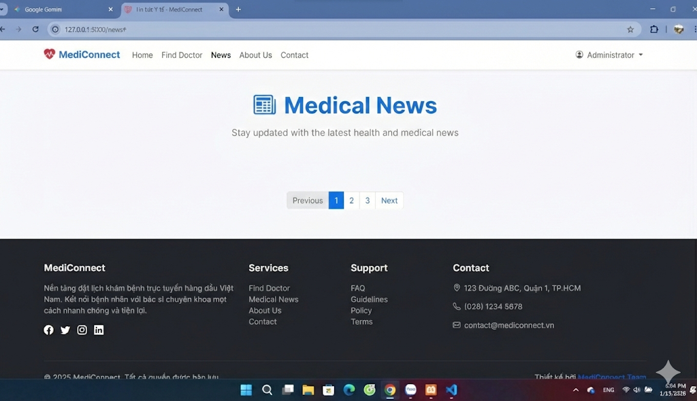

**ADMIN DASHBOARD**

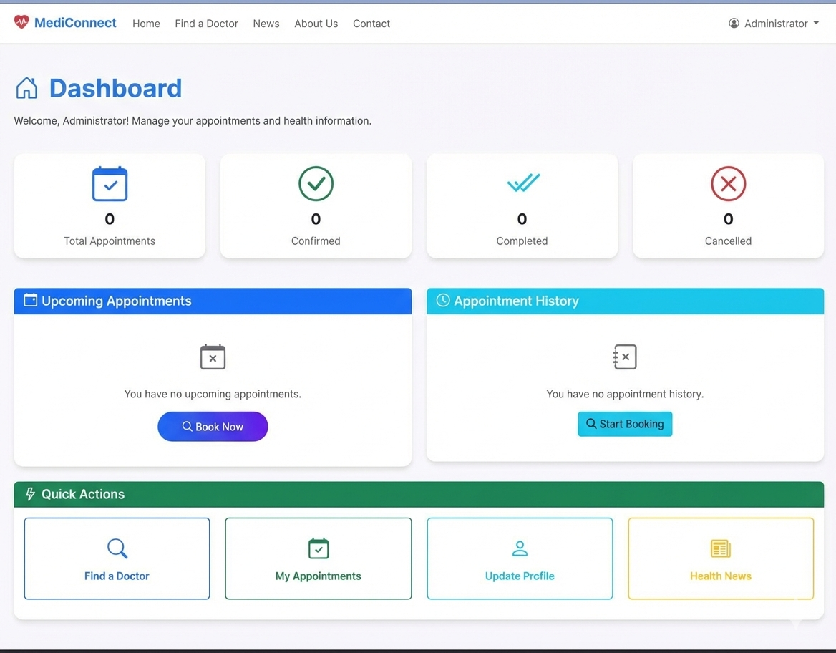

**DOCTOR LIST AND SEARCH**

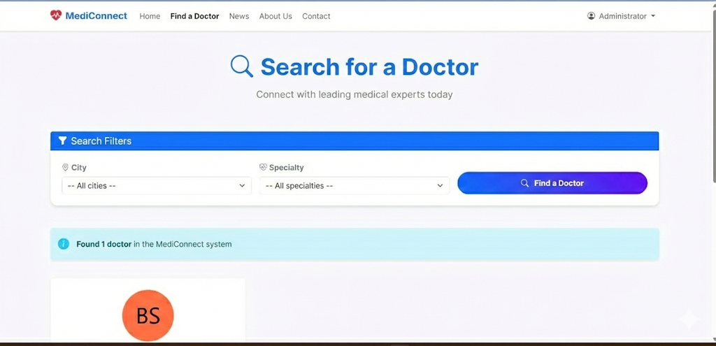

**ABOUT US**

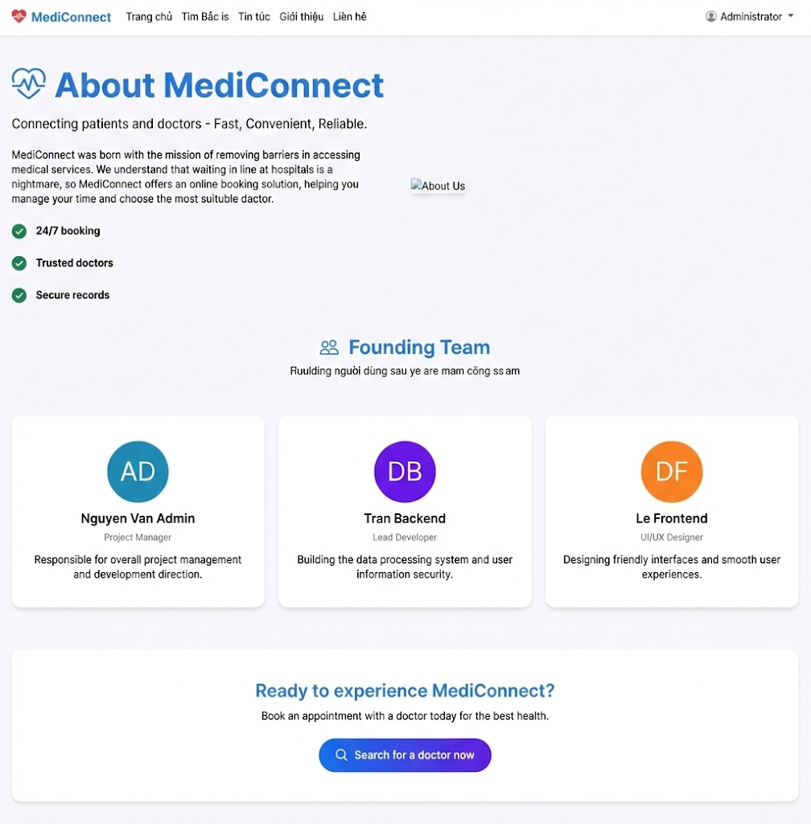

**CONTACT US**

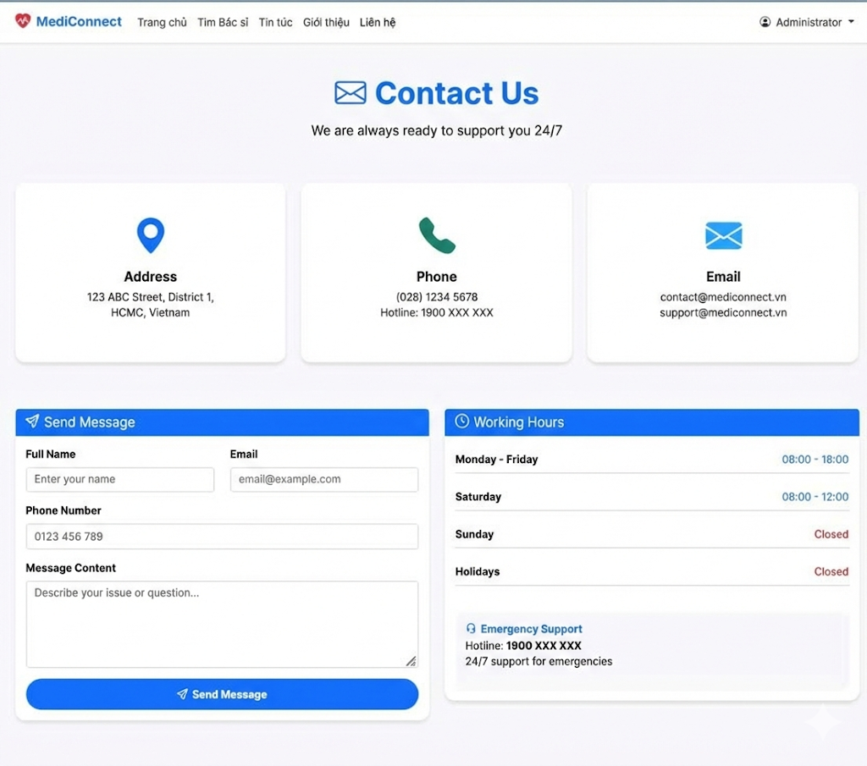

**LOGIN PAGE**

**REGISTER PAGE**

**Bảng phân công công việc**

|  |  |  |
| --- | --- | --- |
| **Name** | **Job** | **Participation(%)** |
| **Đào Nhuận Phát** | **Patient Feature**  **(book appointment, feedback, update profile)** | **100%** |
| **Mai Trọng Tín** | **Doctor Feature**  **(manage schedule, approve appointment, update profile)** | **100%** |
| **Huỳnh Thuận Đạt** | **Admin Feature**  **(manage accounts/news/feedbacks/cities/specialists)** | **100%** |
| **Lê Trọng Hoàng** | **Login and register, change password, homepage, UX/UI** | **100%** |